
Name: ______________________ Time: 10 minutes (strict) Total Marks:____/5 Weighting : 2%
Year 10
OLNA class

Quiz 8- 2021

Probability

Resources: No calculator allowed

1. | 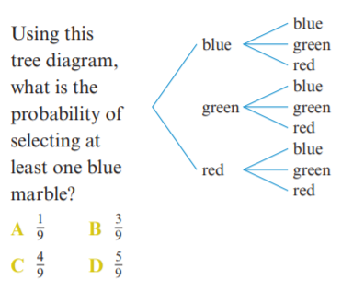
2. | 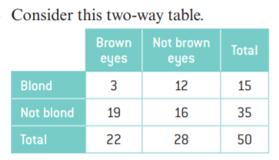  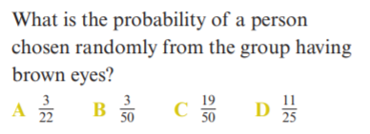
3. | 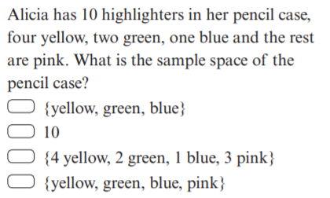
4. | 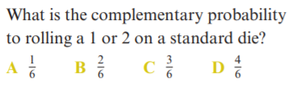
5. | 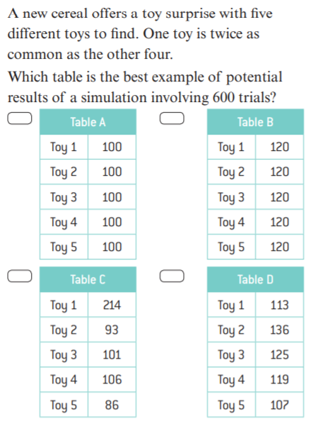

End of Test

